The Certificate in Church Tithing

The Certificate in Church Tithing is a specialized training designed for Church Ministers and or individual associates recommended by the leadership of the local church.

TABLE OF CONTENT
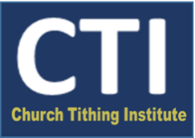
A non-degree Distance Education Program designed for Optimizing the Spiritual and the Financial Vitality of the Local Church.
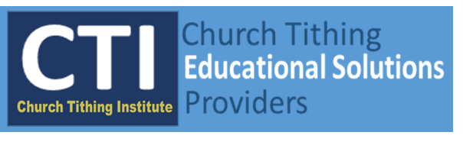
Receive your Church Tithing Educational Solutions Training at the convenience of your own place and location.
We are here to help!
Church Tithing Institute

www.ctionline.com

Preface V

Program Descriptions – General 11

MODULAR I
The Theological and Biblical Foundations of Church Tithing 11
Course Descriptions 12
Christian Theology and the Tithing of Abraham 12
The Legitimacy of Church Tithing 12
The Status of Abraham and Melchizedek in God’s
Church Tithing Program 12
MODULAR II
A Historical Survey of Church Tithing 12
Course Description 13
A Historical Survey of Church Tithing 13

MODULAR III

The Foundational Principles of Church Tithing 13
Course Descriptions 13
The Rubrics of God for Church Tithing 13
The Biblical Assumption of Giving 13
The Five Christian Persuasions of Church Tithing 14
The Spiritual Dynamics of Church Tithing 14
The Sacred Dynamics of Church Tithing 14
The Fundamental Benefits of Church Tithing 15

MODULAR IV

The Curricular Approach of Church Tithing in the
Local Church 14
Program and Course Descriptions 15
The Teaching Aspect of the TCP of Church Tithing 15
The Communication Aspect of the TCP of Church Tithing 16
The Practicing Aspect of the TCP of Church Tithing 16

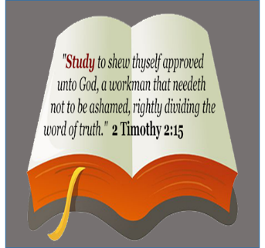

The Program Objectives 18
Learning Outcomes 18
Course Deliverables 19
Reading Assignments 19
Independent Study 19
Comprehensive Quiz 19
Zoom/Webinar Sessions 20
On-Lesson Discussions 20
Special Projects 20
Computer Requirement 21
Grading Criteria 21
Grading Scale 21
How Long Does the Program Run? 21
Program Evaluation 21
Tuition Cost and Application Fee 22
Application to Enroll in the Program 22
Enrollment Requirements 22
Application Deadlines 22
Refund Policy 22
Certificate 22
Textbooks Required for the Course 23
Program Tutor 24
Church Tithing Institute – General Information 25

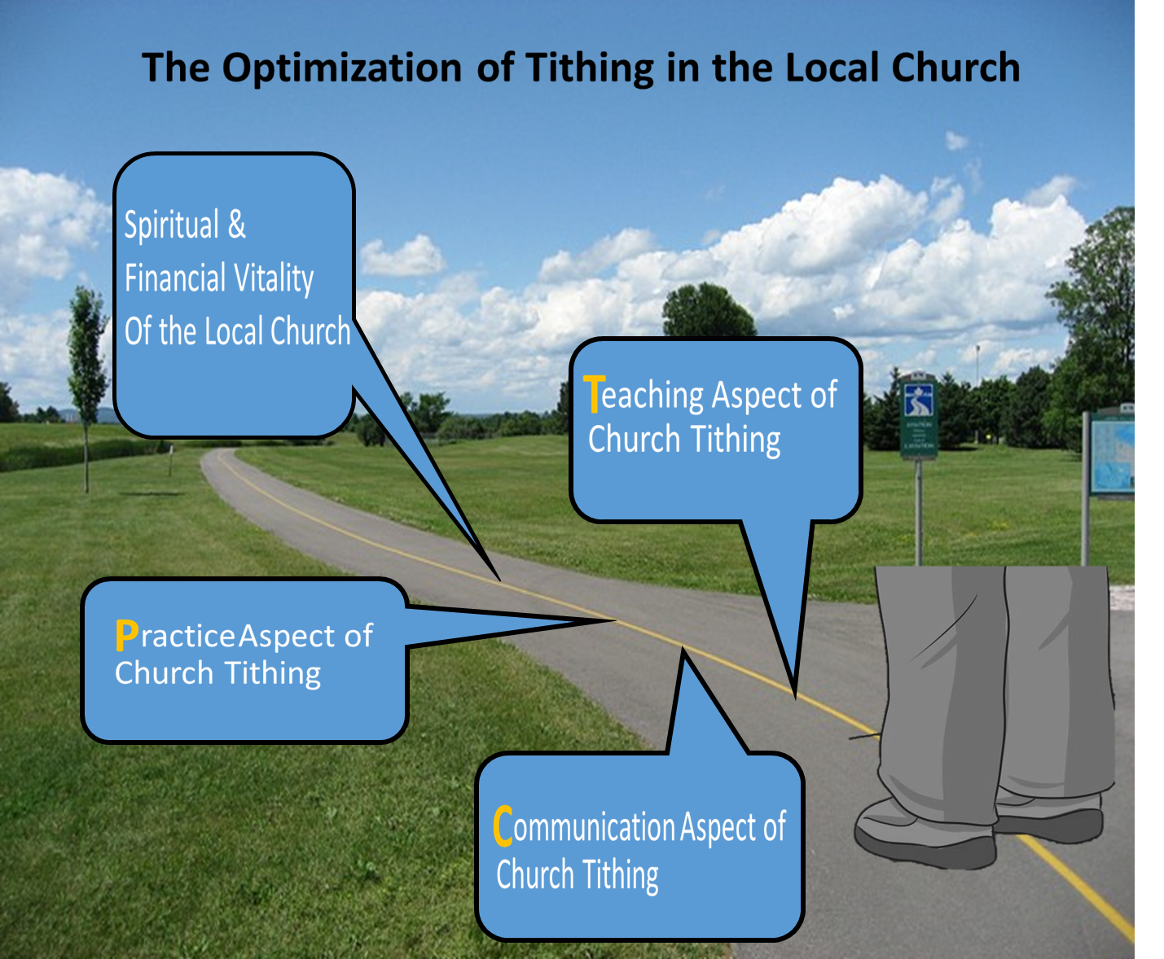

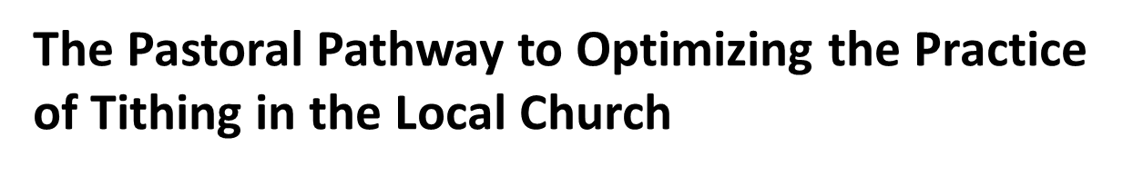

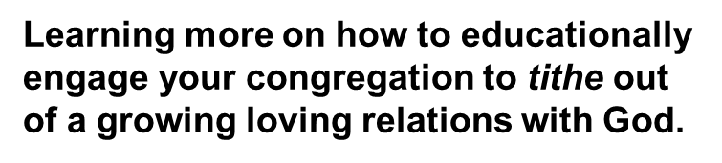

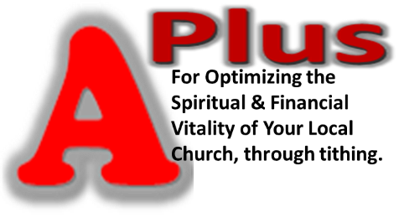

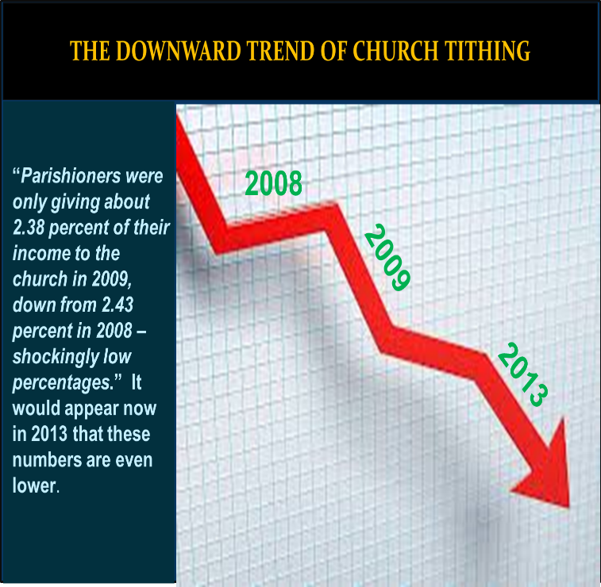

It is a known phenomenon that tithing in local churches has been on a downward trend. Church members are financially giving less in tithing. This trend of less giving in tithing in the local church is reflected in a study conducted by Empty Tomb Inc.

The central point made by Empty Tomb Inc. with this study is in the following intimation:

“If Americans who identify with the historically Christian church had chosen to give 10 percent to their congregation in 2008, rather than the 2.43 percent given that year, there would have been an additional $172 billion available for work through the church.”

Besides this downward trend, the phenomenon also exists that tithing is a sensitive subject for pastors to touch on. Is there anything to be done that would make the giving of the tithes a much joyful experience and optimize the practice in the local church? The answer comes with a big YES. The Church Tithing Institute (CTI) is a leading solution provider set up to bring about the optimization of Church tithing in the local church, through education. CTI has created the pedagogical scheme to bring about the optimization of the practice of Church tithing for the spiritual and financial vitality of local churches.

V
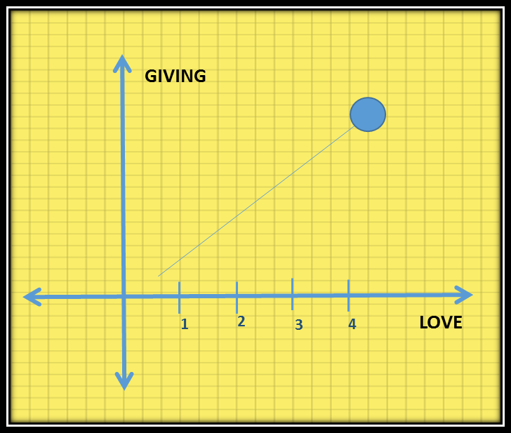

The Church Tithing Institute has explored on the fact that giving is a part of Christian/spiritual formation, so that the behavior of tithing in the local church can be affected with the application of the principles of transformative education. In cognizance of this awareness, CTI has capitalized on the biblical assumption of giving as shown with the following graph, to develop a pedagogy of teaching, communication, and the practicing (TCP) of Church tithing that would create a God focused relational driven culture of church tithing in the local church. This culture involves a church tithing devotional experience the church congregants would have with God, prior to the giving of their tithes at church that would educationally bring them to have a formed habit of giving their tithes out of a spiritually growing trusting and loving relations with God.

vel

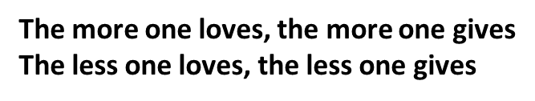

VI

This church tithing devotional experience the congregants would spiritually have with God, prior to the giving of their tithes at church is illustrated with the following diagram:

The effect of the TCP of Church tithing pedagogical scheme is to move the parishioner from Practice A, (where the parishioner usually approach the giving of the tithes only by putting it in an envelope and dropping it in the offering tray or bowl), to Practice B, (where the Parishioner now connects the giving of the tithe with an intentional daily devotional quality of time with God related to the five Christian persuasions for Church tithing, prior to the presentation of the tithe at church).

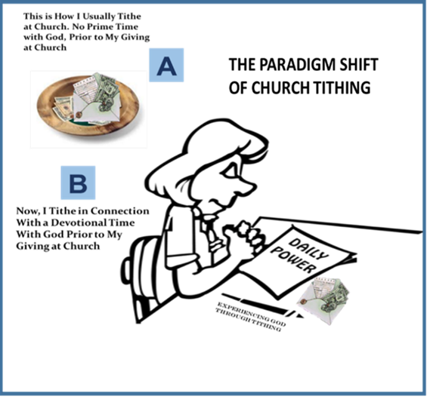

VII

Essentially, as part of Christian/spiritual formation, the TCP of Church tithing opens the local church congregation to the following 5 Christian persuasions for Church tithing.

The formed habit of giving the tithes out of a spiritually growing trusting and loving relations with God occurs in the local church as the congregants get into the devotional pursuit to have fulfillments in the 5 Christian persuasions for Church tithing. A breakdown of how the TCP of Church tithing would affect the Christian/spiritual formation of the local congregation is presented by the following pedagogical scheme:

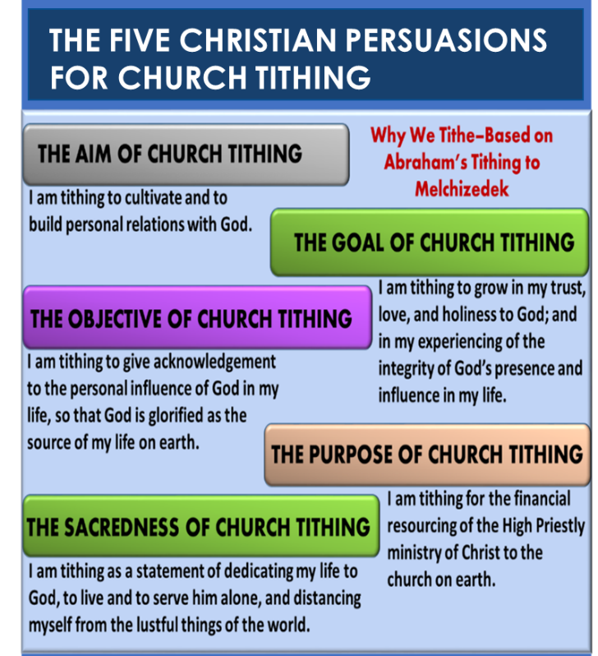

VIII

In addition to the pedagogical framework, the Church Tithing Institute’s educational solutions for optimizing the practice of Church tithing in the local church have the precepts to give the promulgation of the God focused relational culture of Church tithing a solid theological and biblical foundation.

The efficacy of the Church tithing curriculum is built with proven adult learning theories on how people learn and acquire new knowledge, and the dimensions of transformation that take place in their lives. The curriculum draws from the disciplines of philosophy, psychology, education, instructional design, and Christian theology; and a total dependence on the power and influence of the Holy Spirit for fostering transformation in our lives.

In an Online Distance Education Program, the Church Tithing Institute has prepared the Certificate in Church Tithing to train Church Ministers with the theological, biblical, and the curricular essentials of Church tithing. So, that they are enabled with the theological and biblical foundations, the fundamental premises and principles, and the pedagogical tools/manuals to educationally create a God-focused relational driven culture of Church tithing, for optimizing the spiritual and the financial vitality of their churches.

Peace and Many Blessings
Samuel Kirk Mills, ED.D.

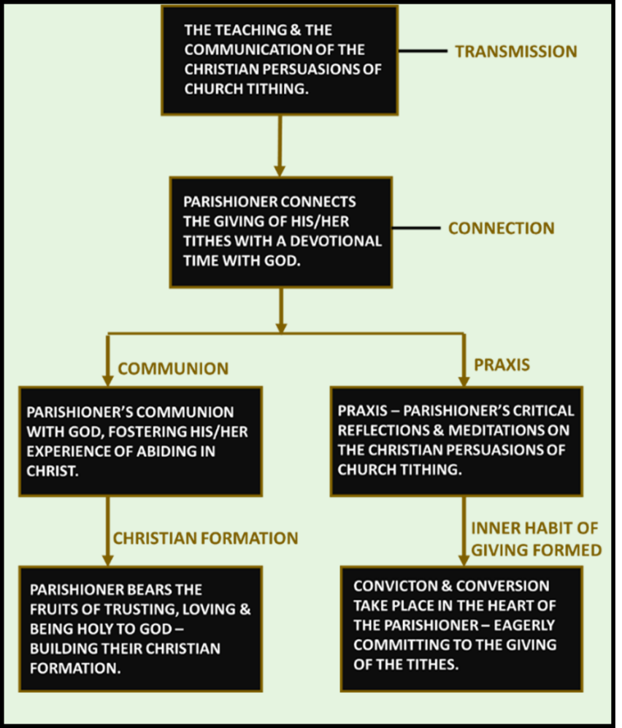

IX

The Certificate in Church Tithing is a 12-week non-degree distance education program designed to prepare Church ministers with the theological, biblical, and the curricular essentials of Church tithing. So, that they are enabled with the theological and biblical foundations, the fundamental premises and principles, and the pedagogical skill sets to educationally create a God-focused relational driven culture of Church tithing, for optimizing the spiritual and the financial vitality of their local congregations.

The Certificate in Church Tithing has four Modular areas of Course study that student would cover to complete the program:

Modular 1. — The Theological and Biblical Foundations of Church Tithing
Modular II. — A Historical Survey of Church Tithing
Modular III. — The Foundational Principles of Church Tithing
Modular IV. — The Curricular Approach of Church Tithing

MODULAR I

The Theological and Biblical Foundations of Church Tithing

In the words of Dr. Jon Cook, ‘theological study is essential to build the framework every Christian need to develop a practical understanding of God and his ways.’ The Theological and Biblical Foundations of Church tithing is focused on equipping students with the using of the Christian theological aspects of the Plan, Work, and the Nature of God; and the appropriation of the correct biblical perspectives to make meaning of the tithing of Abraham to Melchizedek for two things: Strengthen their Christian apologetics (the defense) of the practice of Church tithing today. Entrenchment in the theological and biblical foundations that support the pedagogy (the teaching and the practice) of Church tithing that would create the God focused relational driven culture of giving, with the goal of optimizing the spiritual and the financial vitality of the local church.

The Theological and Biblical Foundations of Church Tithing consists of the following lessons:

- Christian Theology and the tithing of Abraham
- The Legitimacy of Church Tithing today
- The Status of Melchizedek and Abraham in God’s Church Tithing Program

Course Descriptions

Christian Theology and the Tithing of Abraham
Students are given the Christian theological precepts from the knowledge and the understanding of the: 1. Plan and Work of God 2. Nature of God (the impersonal and personal nature of God) to explain how the tithing of Abraham was caused by God, and the reasons why God made him to tithe, in making him the father of the Christian faith. Students receive the theological precepts to make implications of Abraham’s tithing as a pursuit of knowing and relating to God, personally, which gives the grounds for making Church tithing a God focused relational driven culture of giving that would affect the congregations’ spiritual and sacred relations with God, through their giving.

The Legitimacy of Church Tithing Today
In this lesson, students are equipped with the biblical precepts to articulate the validity of the practice of Church tithing today as an ordinance made by the Lord. Students receive the precepts to make an exegesis of Paul’s didactics on Christian giving in 1 Corinthians 9:11-15, to articulate the validity of Church tithing today. Students also receive the biblical precepts to make distinction among parameters, principles, and purpose to show that tithing is a principle and or an application of giving that God established for the Church, to serve the purpose of the priestly ministry of Christ. And that among other two basic applications required for the concept of His priestly services to His people, the principle and the purpose of tithing had remained the same with Abraham, Israel, and today the Church. It is rather the parameters of the giving of the tithes, as among other things that God changed.

The Status of Abraham and Melchizedek in God’s Church Tithing Program
Students will engage with the significance that God gave to Abraham as the father of the Church, and to Melchizedek, as the prototype of the High Priestly Ministry of Christ to the Church. In this lesson, students will work with an analogical instrument to treat Abraham’s tithing and Melchizedek’s receipt of his tithes as foreshadow to the practice of Church tithing, which greatly complements the Christian apologetics for the practice of tithing in the local church today.

MODULAR II

A Historical Survey of Church Tithing

This lesson introduces students to the historical trends of Church tithing beginning in the 4th century with Emperor Constantine, the influence of the Catholic Church in the 6th century, its proliferation in the 1500s with the emergence of the Protestant churches, to its present state especially with the Evangelical Church Movement. The ethos of this lesson is to give students the framework to critique the biblical premise that founded the origination of the practice of tithing in the local church, that has stayed its practice even to the present. The objective of this critique is to engage students to form the correct and the true biblical foundation consistent with

the theological tenets of the New Testament, for the teaching and the practice of the Church tithing that God benchmarked with the tithing of Abraham for the spiritual and sacred benefit of the Church.

Course Description

A Historical Survey of Church Tithing
This lesson is designed to engage students to know and to form the correct Christian perspective concerning the influence of God in Emperor Constantine’s historical origination of today’s Church tithing. It will enable them to determine and explain the correct biblical foundation for today’s Church tithing that God established with Abraham.

MODULAR III

The Foundational Principles of Church Tithing

On the grounds of the theological and biblical bases of God’s modeling of Church tithing with Abraham, students will cover in this study the essential things that give integrity, credibility, and consistency to the Foundational Principles that God benchmarked in Abraham to serve as the underpinnings for Church tithing. From the standpoint of giving importance to God and his ways with Church tithing, students need to know and be entrenched in these Foundational Principles of Church tithing for optimizing its practice in the local churches, according to the established standards of God. The Foundational Principles of Church tithing consists of the following lessons:
- The Rubrics of God for Church Tithing
- The Biblical Assumptions of Giving
- The 5 Christian Persuasions for Church Tithing
- The Spiritual Dynamics of Church Tithing
- The Sacred Dynamics of Church Tithing
- The Fundamental Benefits of Church Tithing

Course Descriptions

The Rubrics of God for Church Tithing
In this lesson, students will address the sum of 4 essential things that constitute as Church tithing, which are (Fellowshipping with God, Dedicating lives to God, Committing to the Kingdom agenda of God, and the Giving of the tithes. Students gain the knowledge and the understanding in how these 4 essential things serve as the rubrics of God that meet the spiritual and the sacred nature of the Church tithing that God benchmarked with Abraham that are to be discernible in the way it is practiced in the local church.

The Biblical Assumption of Giving
In this lesson, students are engaged to address the fundamental biblical truth in the correlation that exists between love and giving, such that the more one loves the more one gives, the less one loves, the less one gives. Based on this fundamental biblical assumption of giving, the lesson guides students to assess the importance for the pedagogy and practice of Church tithing that focus on creating a culture of giving that has the congregation inclined to the discipline of connecting their tithing with a spiritual communing relationship with God. Students will examine this educational thrust for Church tithing as an approach for developing the congregation’s spiritual loving relations with God towards optimizing the spiritual and the financial vitality of the local church.

The 5 Christian Persuasions for Church Tithing
This lesson focuses students to gain the knowledge and the understanding of how Abraham’s tithing yielded the five Christian persuasions for Church tithing, which are the aim, the goal, the objective, the purpose, and the sacredness of Church tithing. The lesson guides students to examine the importance for the need to be deeply rooted in the five Christian persuasions for Church tithing, which hosts the entire content for the objectives in the teaching, communicating, and the practicing of Church tithing that would create the God focused relational driven culture of giving, for optimizing the spiritual and the financial vitality of the local church.

The Spiritual Dynamics of Church Tithing
In this lesson, students will gain the knowledge and the understanding of the critical importance for fostering in the local church, the congregants’ habit to connect the giving of their tithes with a Church tithing devotional discipline, as a way of cultivating and growing in their spiritual trusting and loving relations with God, from which their giving would take place. The lesson guides students to examine this critical importance of Church tithing in the context of the spiritual nature of Abraham’s tithing to Melchizedek, as a benchmark that God touted with the patriarch of the Christian faith, to give credence to what is to be the spiritual nature of Church tithing today in the local church.

The Sacred Dynamics of Church Tithing
In this lesson students will discover that Church tithing is a sacrament. Students will engage with that fact, as they explore that meaning in Melchizedek’s receipt of the tithes from Abraham in association with the ‘bread’ and the ‘wine’ he came along with, and that he sanctified and consecrated Abraham in the Lord at the receipt of his tithes. This lesson is intended to help students form a biblical perspective concerning the need to conduct the receipt of the tithes in the local church along with the administration of the Holy Communion, which allows the parishioners/congregation to be sanctified and consecrated in the Lord at the giving of their tithes, as part of achieving the rubrics of God for Church tithing and the nature of the sacredness it exudes.

The Fundamental Benefits of Church Tithing
In this lesson, students are engaged to explore the spiritual growth patterns in Abraham’s life after his tithing, showcasing the integrity of God’s personal presence established in his life, and the increase in his trust, love, and holiness to God. Through this lesson, students will gain the knowledge and the understanding in how the fundamental benefits of Church tithing transcend physical rewards. With Abraham as the example, student will examine and appreciate the practice of Church tithing in the local church as a standardized application of giving by God’s establishment that the Church would utilize to cultivate personal relationship with Him, with the goal of growing in their trust, love, and holiness to Him.

MODULAR IV

The Curricula Approach of Church Tithing in the Local Church

There is an educational dictum stated in this saying: The purpose of education must inform the practice of education; the practice of education must bring out the purpose of education.

We can state this dictum in terms of Church tithing. In this way: The purpose of Church tithing must inform the practice of Church tithing; the practice of Church tithing must bring out the purpose of Church tithing.

The purpose and practice of Church tithing cannot be separated.

Program and Course Descriptions

In this program of study, students are equipped with the tools and manuals they need to follow through with the Foundational Principles of Church Tithing to create the God focused relational driven culture of Church tithing, for optimizing the spiritual and financial vitality of the local church.

The main curricular guide students will work with in this program is the TCP of Church Tithing Program Kit for teaching, communicating, and the practicing of tithing, for generating the God focused relational driven culture of Church tithing in the local church.

The Teaching Aspect of the TCP of Church Tithing
Students are tutored to get accustom with the focus of the teaching, which is mainly to achieve through instruction a common knowledge and understanding in the local church congregation concerning the five Christian persuasions for Church tithing with regards to the aim, goal, objective, the purpose, and the achievement of the sacredness of Church tithing that came out of Abraham’s tithing; and its principal objective to inculcate in the local church congregation the need to connect the giving of their tithes with a church tithing devotional to gain fulfillments in these 5 Christian persuasions for Church tithing.

Students are required to do a teaching practice on the teaching series of the TCP of Church tithing and submit a report on their teaching experience of that series, for assessment.

The Communication Aspect of the TCP of Church Tithing
Students are tutored to get accustom to the focus of the communication on Church tithing, which is to reinforce in the local church congregation the teaching lessons of the 5 Christian persuasions for Church tithing; and its objective by reinforcement messages – ‘Tithing Tips’ that would inspire and motivate the local church congregants to connect the giving of their tithes with a church tithing devotional, to gain fulfillments in the 5 Christian persuasions for Church tithing, and which would put them on the path for growth in their Christian faith, as part of their Christian/spiritual formation.

Students are required to do a calendar year-long communication program guide for disseminating church tithing tips for the local church congregation and submit their work for assessment.

The Practicing Aspect of the TCP of Church Tithing
Students receive tutoring to get accustomed to the Tithing to Grow in Christ Devotional Workshop designed for the local church congregation to experience the possibility of connecting the giving of their tithes with a Church tithing devotional time with God before they come to give their tithes at church.

Students also receive tutoring to get accustomed to the Liturgical Practice of receiving the tithes from the congregation – connecting the receipt of the tithes with the fellowshipping in the Holy Communion and other liturgical expectations.

Students are required to do a simulative workshop exercise on the Tithing to Grow in Christ Devotional Workshop and submit a report of their experience for assessment.

Students are also required to do a simulative exercise on the Liturgical Practice of Church tithing and submit a report of their experience for assessment.

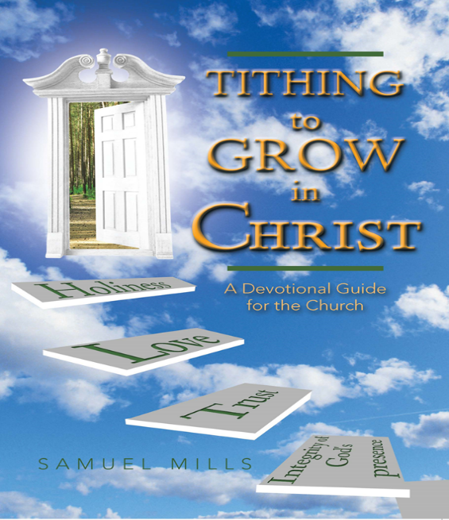
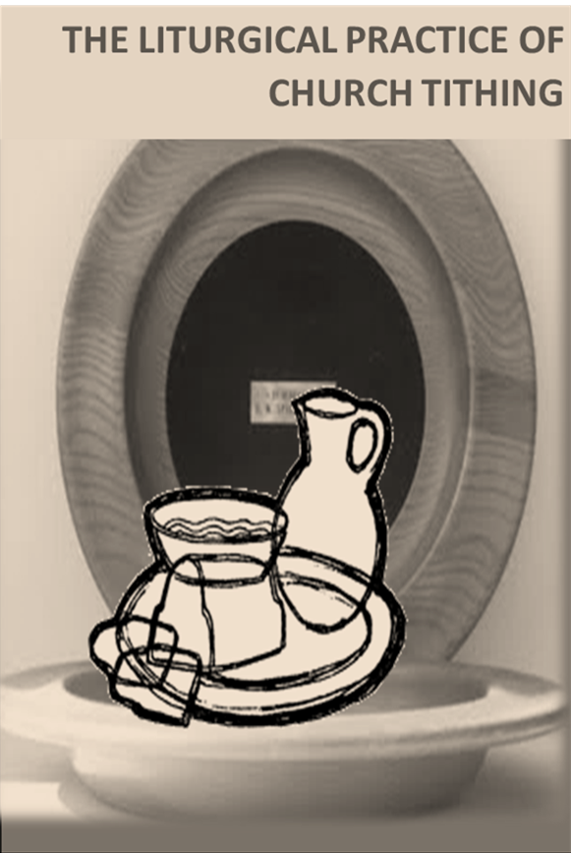

For Achieving the Sacred Dynamics of Church Tithing
For Achieving the Spiritual Dynamics of Church Tithing

Learning Outcomes
At the end of taking the Certificate in Church Tithing, students would be able to:

- Use Christian theological and biblical precepts to make implications of Abraham’s tithing to the practice of Church tithing today
- Defend the legitimacy of Church tithing today with the intimations of Paul in 1 Corinthians 9:11-15, and using the distinctions among parameters, principles, and purpose
- Construct the biblical view that gives significance to the tithing of Abraham and Melchizedek’s receipt of his tithes as foreshadow to the practice of Church tithing as a unique application of giving by the church, for the purpose of the High Priestly ministry of Christ to the Church
- Know and to give due diligence to the Foundational Principles that God benchmarked with the tithing of Abraham as underpinnings for the practice of Church tithing
- Instruct by teaching to achieve common knowledge and understanding in the local church congregation concerning the 5 Christian Persuasions for Church tithing, to gain fulfillments in them, and so create a God focused relational driven culture of Church tithing, for optimizing the spiritual and financial vitality of the local church
- Design a calendar year-long communication program to message ‘Church Tithing Tips’ to reinforce in the local church congregation the lessons learned concerning the 5 Christian Persuasions for Church Tithing, to gain fulfillments in them, and so create a God focused relational driven culture of Church tithing, for optimizing the spiritual and financial vitality of the local church
- Conduct the Tithing to Grow in Christ Devotional Workshop, to give the local church congregation a prevue to the plausibility in connecting the giving of their tithes with a daily spiritual communion with God and experience Christian growth in their trust and loving relations with Him. So that the congregation would have the psychological and spiritual disposition to giving their tithes out of a growing trusting and loving relations to God
- Use the Liturgical Practice of Church Tithing Manual to conduct the liturgy for the receipt of the tithes from the congregation, to achieve the sacred nature of the Church tithing that God benchmarked with Abraham

Essentially, Church Ministers receive the training to engage in a robust comprehensive pedagogy and practice of Church tithing to achieve with their congregation, the spiritual and the sacred nature of Church tithing and their outcomes for growth in the Christian faith that God instituted with the tithing of Abraham; with the goal of optimizing the spiritual and financial vitality of their churches.

Course Deliverables

The Certificate in Church Tithing is an online non-degree college equivalent program for qualified Church Ministers who are to enroll as students. Students will access the Course lessons through the Thinkific Course site and participate in a series of engaging-interactive-instructional sessions on Zoom/Webinar e-learning platforms under the tutelage of highly qualified Program Tutors.

Reading Assignments

Students will complete weekly reading assignments for each Modular course requirements. Students will earn 10 cumulative points for successfully completing all reading assignments.

Independent Study.

Each week, at the Thinkific Course Site students will engage in independent study lessons. The study lessons are usually provided in a text format. Students will study the lessons in Modular I, Modular II, Modular III and Modular IV in that sequence to complete the Course. The independent study lessons are to get students to interact with the assigned reading chapters of the textbook and to keep the diligence in participating in the Course community learning engagements (On-lesson Discussions).

At the end of each major course lesson of the Modular coursework, students will take a quiz. These quizzes are used as students’ self-assessment tool to measure learning. Immediately practicing what has just been learned helps students gauge their progress with the material, and helps it stick. If students struggle to recall the lesson, then they will know to revisit it.

Students will earn 30 cumulative points for successfully completing the independent study lessons. The study lessons for each Modular are dripped to keep students on the same pace with others, to the completion of the Course.

Comprehensive Quiz
Based on their reading assignments, independent studies, and participation in Zoom/Webinar sessions, for each Modular course work, students will complete a comprehensive quiz online. The comprehensive quiz is designed as an overall student assessment of what they have learned in the Modular course work. The comprehensive study quiz constitutes 40 cumulative points.
Please Note: The quizzes are part of the due diligence students are to give to fulfilling the requirements for completing the Course.

Zoom/Webinar Sessions

For each Modular course requirement, students will participate in a two-hour zoom/webinar session with the tutor, once a week. For the convenience of students, the zoom/webinar sessions are scheduled twice, mornings and evenings on the day slated for the sessions. So that students may choose the time convenient for their participation in the zoom/webinar sessions. Students earn 30 cumulative points for participating in the zoom/webinar sessions.

On-Lesson Discussions

Students will participate in On-lesson discussions for each lesson of the Course. This is an exercise for students to collegially share their thoughts, concerns, and the insights that they are gleaning from the Course. Usually, the instructor will initiate the discussion thread with a question that he/she will post, and it is expected for students to post their responses. For grading purposes, each student is expected to post at least 1 question related to the trending course lesson. Each student is also expected to at least post 1 response to a minimum of 5 questions/concerns/thoughts/insights posted by a student. On a scale of 0-20 points, students will receive grading points for their participation in the On-lesson discussion. Please Note: The On-lesson discussions are part of the due diligence students are to give to fulfilling the requirements for completing the Course.

Special Projects

As part of the fulfilling requirements to complete the Course, students will do special projects.

- Students will do a teaching practice on the teaching series of the TCP of Church tithing and submit a report on their teaching experience of that series, for assessment.

- Students will do a calendar year-long communication program guide for disseminating church tithing tips for the local church congregation and submit their work for assessment.

- Students will do a simulative workshop exercise on the Tithing to Grow in Christ Devotional Workshop and submit a report of their experience for assessment.

- Students will do a simulative exercise on the Liturgical Practice of Church tithing and submit a report of their experience, for assessment.

Students will submit a progress report and a final report on their special project following guidelines provided by the tutor. On a scale of 0-30 points, students will receive grading points for the timely submission, and the quality of their reports on their special projects. Please Note: The special project assignment is part of the due diligence students are to give to fulfilling the requirements for completing the Course.

Computer/Mobile Requirement

Students will need to have access to a computer with up-to-date browser, and operating systems, or mobile tablets or phone for this Course. Some documents for this Course will be made available to you in PDF format. If you do not have Acrobat Adobe Reader software on your computer, you can download it by going to http://get.adobe.com/reader/.

Grading Criteria

Points Possible

ASSIGNMENTS | POINTS
Participation in Zoom/Webinar Sessions | 30
Reading Assignments | 20
Independent Study | 30
Comprehensive Quiz | 40
Special Projects/Assessment | 30
Total Points: | 150

Grading Scale

LETTER GRADE | PERCENTAGE | REMARKS
A | 90-100% | Distinction
B | 80-89% | Superior
C | 70-79% | Average
D | 60-69% | Below Average
F | 59% and Below | Poor Average

How Long Does the Program Run?

On an academic quarter system, the Church Tithing Institute is a 12-week intensive program. The program is offered twice in the calendar year scheduled as follows:

March through the 1st week of June (Spring Program)
September through the 4th week of November (Fall Program)

Program Evaluation

Students get to evaluate the effectiveness and efficiency of the program at the completion of the Course. CTI is big on delivering quality educational program. As a student-centered learning institution, our students are regarded the best providers of the input we need to improve on the quality delivery of our educational program.

Tuition Cost and Application Fee

Tuition cost for the program is $1200. A nonrefundable application fee of $100 must accompany the application for enrollment.

Application to Enroll in the Program

We accept online application only, to enroll in the program with tuition payments and the application fee. Students are required to choose the scheduled program they would like to be enrolled in when they do the application.

Enrollment Requirements

The program uses a selective process for enrollment. This process considers applicants who are Church Ministers and or individual associates recommended by the leadership of the local church.

As an equivalent higher education program, applicants must demonstrate that they can pursue a tertiary level course work.
Application Deadlines

All application materials must be received by the following appropriate deadlines to ensure priority consideration.

Registration for enrollment deadline for the Spring Program (March through the 1st week of June) — February 1.

Registration for enrollment deadline for the Fall Program (September through the 4th week of November) — August 1.

Refund Policy

Students may withdraw from the program at any time before the beginning of the Course. Students withdrawing from the program within two weeks before the beginning of the Course receive 60% refund of tuition paid. Students withdrawing from the program within a week before the Course begins would receive 30% refund. No refund is made when the Course has begun, and students choose to withdraw from the program.

Certificate

Students receive the Certificate in Church Tithing, after completing all requirements for the Course and graduate as a Church Tithing Specialist.

Textbooks Required for the Program
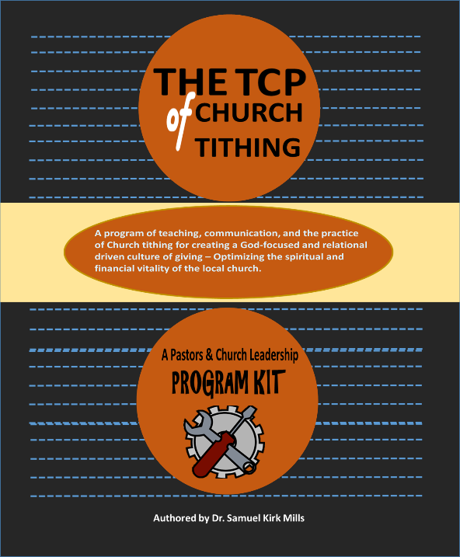
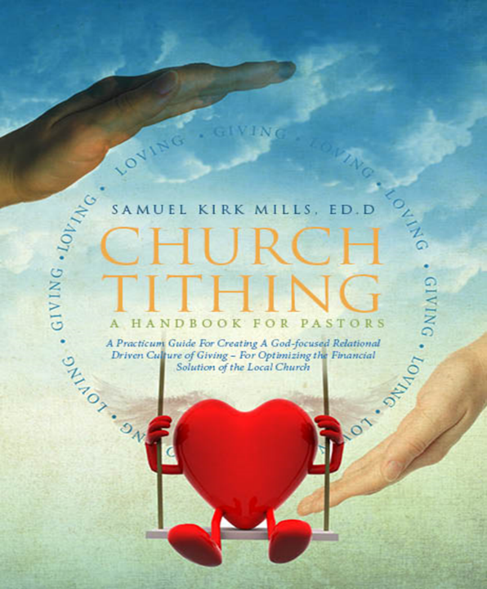

Dr. Samuel Kirk Mills has been engaged in Christian Ministry for 40 plus years. He studied at Moody Bible Institute, the Wheaton Graduate School as a Billy Graham Scholar, where he graduated with the Master of Arts degree in Educational Ministries. He subsequently earned his doctoral degree in education from Northern Illinois University. An astute teacher and speaker in the foundations of Church ministry, Dr. Mills is charting a course for Church Ministers that would equip them with a Church tithing practicum for optimizing the spiritual and financial vitality of their churches—supporting local churches to thrive for the cause of Christ and His Kingdom.

STATEMENT OF PURPOSE
The Church Tithing Institute is a leading Church supporting organization dedicated to providing the educational solutions for efficient and effective practice of Church tithing in the local church. So that the local church can optimize its spiritual and financial vitality.

MISSION
CTI is established to endow Church Ministers and their leadership with the theological, biblical, and curricular skill sets to create a God focused relational driven culture of Church tithing that would optimize the spiritual and financial vitality of their local churches.

CTI is big on the education that transforms the individual in being formed in Christ. The efficacy of the Church tithing curriculum is built with proven adult learning theories on how people learn and acquire new knowledge, and the dimensions of transformation that take place in their lives; with a total dependence on the power and influence of the Holy Spirit who is the arch agent in fostering the Christ-driven transformation in our lives.

INSTITUTIONAL OBJECTIVES
To fulfill its purpose and mission, CTI is committed to providing a distance educational program that would prepare Church Ministers and their leadership in the knowledge and the application of:

- Christian Theology and Church Tithing
- The Significance of Abraham and Melchizedek Related to Church tithing
- Historical Trends of Church tithing from the 4th century to the Present
- The Essential Principles of Church tithing
- The Pedagogy and Practice of Church tithing

CTI shares the responsibility with Church Ministers and their leadership in being entrenched in the theological and biblical bases of God’s modeling of Church tithing with Abraham, being able to defend the practice of Church tithing, and giving due diligence to the essential things that give integrity, and consistency to the fundamental principles that God benchmarked in Abraham, to serve as the sustaining underpinnings for the practice of tithing in the local church.

North Carolina College of Theology Catalogue, pg. 12

